

217, Sheikh Rashid Building

P.O Box 56272, Dubai

United Arab Emirates

Tel: +971 4 2973236

Email: uae@verbat.com

PROJECT   
PROPOSAL

**Web Portal implementation for**

**UAE National Anti-Doping Committee**

|  |  |
| --- | --- |
| **Prepared for:**  **UAE National Anti-Doping Committee** | **Submission Date:**  28 March 2018  **Proposal ID:** WD/28032018/1912/1 |

________________________________________________________________________________________________________________________________  
Conﬁdentiality Notice: This Proposal is conﬁdential and contains proprietary information and intellectual property of Verbanet Technologies LLC. Neither this proposal nor any of the information contained herein may be reproduced or disclosed under any circumstances without the express written permission of Verbanet.

© 2018 by Verbanet Technologies LLC. All rights reserved. Confidential.

________________________________________________________________________________________________________________________________

Project Contacts

|  |  |
| --- | --- |
| Client Information | |
| Project Name | Website Design Services |
| Client Name | UAE Anti-Doping Committee |
| Client Address | P.O Box 445458  Dubai, UAE |
| Phone Number | +971-4-6071878 |
| Contact Person |  |
| Contact Person Email |  |
| Contact Person Mobile Number |  |
| Verbat Information | |
| Contact Person | Ms. Darshana |
| Contact Person Phone Number | +971 4 2973236 ext 102 |
| Contact Person E-Mail | darshana.s@verbat.com |
| Address | PO Box 56272, Dubai |
| Physical Address | 217, Sheik Rasheed Building, Hor Al Anz East, Dubai |
| Project Information | |
| Proposed Technology/Methodology | Open Source (PHP, MySQL, Code Igniter, CSS3, HTML 5) |
| Anticipate Start Date | NA |
| Proposal Valid For | 30 Calendar days from the submission of the proposal |

**Table of Content**

1 Introduction 5

1.1 Project Overview 5

1.2 Key Differentiators 7

1.3 Underlying Support Services 8

2 Web Design Process 9

3 Proposed Use Case 10

3.1 Content Management System (CMS) Module 10

3.2 Website 10

4 Assumptions 11

5 Out of Scope 12

6 Technology Solution 13

6.1.1 Web site Design 13

6.1.2 Browser Compatibility 13

7 Delivery Management 14

7.1 Project Management 14

7.2 Roles and Responsibilities 14

7.3 Delivery Activity summary 14

7.4 Project Implementation Plan 15

7.5 Deliverables 15

7.6 Deployment Details 15

7.7 Release Planning 15

7.8 Risk and Contingency planning 15

8 Change Management 17

9 Miscellaneous 18

9.1 Acceptance Criteria 18

9.2 Warranty 18

9.3 General Terms and Conditions 18

9.4 Assumptions and Dependencies 19

9.5 Maintenance & Support 20

9.6 Service Level Agreement 21

# Introduction

**Verbat Technologies is pleased to submit this proposal for implementing a new web portal for UAE National Anti-Doping committee (Client)**

The new **responsive** web site will enablethe clientto implement & manage anti-doping policy in the UAE and assist athletes & national sports bodies to ensure compliance with the World Anti-Doping (WADA) Code.

* A professional web presence for the client through use of elegant responsive design and a highly useable interface
* Easy channels for interested parties to connect with client
* A Responsive, scalable, modular web platform that will allow future functionality to be seamlessly integrated
* Fully secured & automated workflows to provide better services for the audience and increase the operation efficiency
* Verbat Technologies is uniquely qualified to help design the website because of its;
  + Expert consulting, creative and development staff
  + Vast experience working with CMS systems and custom development to help clients achieve strategic goals online
  + Proven record of executing strategic, high-level projects for large, diverse and dispersed audiences

## Project Overview

Verbat Technologies is a team of Digital Technology experts including consultants, web developers, graphic designers, programmers, marketing and SEO experts. Our specialty is creating modern, interactive, responsive and SEO ready websites. The project is to design and develop the bilingual (English & Arabic) website using open source technologies such as PHP, CodeIgnitor, MySQL, Apache CSS3 and HTML5.

Our web design process starts with the creation of a detailed Use-case and Wireframe followed by Prototype of the website, to ensure that we understand your exact requirements and finishes with hosting in a secured environment.

**“If Opportunities aren’t knocking,   
we can build you a door”**

Our team transforms ideas into carefully crafted solutions that align to your business goals

**We Engineer Digital Success**

Verbat’s close-knit team is spearheaded by Technology leaders and subject matter experts enabling us to deliver sharp Internet and Mobile solutions. Our home-brewed agile development methodology continues to ensure that our solutions trigger seamless business transformation and consistent business growth

Our Numbers Speak Volumes



**18+**Years of Presence

**500+**Successful Projects

**1000K+**  
Man hours of expertise in Microsoft, Open Source, Mobility Platform

## Key Differentiators

Delivered digital transformation expertise to global customers for over a decade by following industry best practices to maximize ROI for client

Keen technology intelligence combined with aggressive market research to deliver solutions that achieve results with measurable value

Enable access to global consulting expertise with strong local market and business knowledge

Commercial Model that is customizable for your business needs

Services that are designed to optimize applications for improved performance and overall efficiency

1,000,000 plus man-hours of expertise in technology frameworks spanning Microsoft, Open Source, mobility platforms and other proprietary IT technology

Partners top technology vendors to bring in the latest and best services in integration, collaboration, and development

Commercial Model that is customizable for your business needs

Proven Methodologies & Processes

Investment in R & D

Strong Local Presence

Flexible commercial Models

Technology Associations

Software Development Experience

Offshore Development Centre

Quality Assurance & Testing

## Underlying Support Services

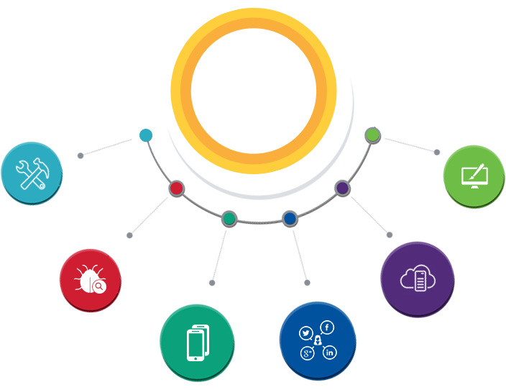

User Interface & Design

Technology  
&  
Services

Cloud/Traditional Hosting

Digital Marketing

Mobility Solutions

Testing Services

Application  
Development

# Web Design Process

1. **Exploration and Discovery**
   * Survey and freeze the proposed use case
   * Conduct planning meetings to discuss and finalize project scope/details
2. **Analysis and Planning**
   * Create wireframes based on confirmed use case (Key Screens)
3. **Design**
   * Present two unique homepage and subpage **design theme**s based on the confirmed wireframe
   * Confirm chosen design theme concept based on feedback
   * Create prototype of the website
   * Conduct meetings to discuss and finalize the prototype
4. **Development and Production**
   * Set up development environment and server
   * Development of the CMS and Front End
   * Prepare graphics/images
5. **Testing and training**
   * Test for full functionality on browsers (refer Brower Compatibility section for details)
   * Conduct one-time training for site editing/updates/administration
6. **Launch**
   * Publish the Web site to Verbat Test Server

# Proposed Use Case

## Content Management System (CMS) Module (Web Site)

|  |
| --- |
| **Super Admin** |
| Dashboard |
| Manage Content |
| About US |
| Anti-doping Rule Violations |
| Medication & Substances |
| Therapeutic Usage Exemptions |
| Anti-doping |
| Awareness & Training Materials |
| Privacy Policy |
| Manage News |
| Manage Events |
| Manage Gallery |
| Manage FAQ |
| Manage Webinar (YouTube URL) |
| Manage Home Slider |
| Contact Us |
| **Client Area** |
| Home |
| News |
| Gallery |
| Contact Us |
| FAQ |
| Content Pages |
| About US |
| Anti-doping Rule Violations |
| Medication & Substances |
| Therapeutic Usage Exemptions |
| Anti-doping |
| Awareness & Training Materials |
| Privacy Policy |
| Webinar |
| Footer Links |
| Multi Language (Arabic) |

## Web App

|  |
| --- |
| Super Admin - |
| Dashboard |
| Manage Roles & Permissions |
| Manage Users |
| Manage Logs |
| Manage Masters |
| Reports (3) |
| Management |
| Dashboard |
| Manage Clubs |
| Manage Doctors |
| Manage Inspectors |
| Manage TUE Requests |
| Manage Clubs/Player DB |
| Reports (3) |
| Clubs |
| Dashboard |
| Manage Players |
| Reports (3) |
| TUE Module |
| View TUE Requests |
| Approve/Reject Requests |
| Inspection |
| View Players Whereabouts |
| Conduct Inspection |
| Doctors |
| View TUE Requests |
| Update Medical Reports for TUE |
| API Development ( Mobile Application) |
| Work Flow |
| TUE Module |
| Whereabouts |

## Hybrid Mobile App

|  |
| --- |
| **Development** |
| Basic Setup |
| Home |
| News |
| Gallery |
| Contact Us |
| FAQ |
| Content Pages |
| About US |
| Anti-doping Rule Violations |
| Medication & Substances |
| Therapeutic Usage Exemptions |
| Anti-doping |
| Awareness & Training Materials |
| Privacy Policy |
| Webinar |
| Login Page |
| Create TUE Request |
| Online Payment |
| View TUE Status |
| Define Whereabouts |
| **App Creation** |
| Android App |
| IOS App |

# Assumptions

The proposed solution is based on the following assumptions to be read along with the General Terms & Conditions mentioned in this document.

1. **Objective**:
   * The requirement is to develop a Website based on the functionalities/ use case as defined in the “Proposed Use Case” section
2. **Design**:

* Client to provide Verbat with the branding guidelines, if required
* Color theme shall be provided by the client
  + Content in English & Arabic shall be provided by the client. Text should be provided in digital format preferably in MS Word 2013 or above
  + Client shall provide licensed images and logos in specified size & format, if applicable
  + Design Effort is based on a design template not from scratch
  + Arabic layout shall cost an extra 30% of the effort

1. **Development**:
   * Requirements should be well defined, agreed and signed-off by the client
   * The website will have English/Arabic language only
   * The proposed website CMS labels would be in English
   * Client will provide sample data to test the CMS modules
   * Payment gateways to be integrated would be shared by the client. Test Account, Test Cards would be shared by the client.
   * Verbat can provide consultancy service in the event client requires Verbat’s assistance in procuring the above services
   * API details, if required, will be shared by the client
   * The client will finalize the Use Case, Wireframe, Design and Prototype before the commencement of the development
   * Client will host and manage the website on infrastructure recommended by Verbat
   * Backups are subject to the purchase of such services at an extra effort
   * Hybrid Mobile App will be developed for English language
   * Hybrid effort estimate may change depending on changes in detailed requirements
   * Content pages of Hybrid Mobile App shall have only one image and one content area
   * Hybrid Apps are slower than native apps. Their responsiveness depends on the internet connection speed and are expected to experience lags. They can only be accessed with an internet connection
   * The website shall be developed in English and Arabic
   * Website content pages shall have only one image and one content area
   * Web site templates shall be purchased by the client
   * CDN shall be used for static content only
   * Due to JavaScript & CSS Limitations, Implementation of AMP Is Not Straightforward

# Out of Scope

Following are considered to be out of scope while creating this proposal.

* Audio & Video production
* Purchase of images, fonts
* Content writing/ procurement or uploading or editing / manual data entry
* Physical deployment at client’s site
* Integration with any other systems other than anything specified in this proposal
* Hardware Integrations / Procurement and Purchase
* Deployment (Physical deployment at client’s site (onsite deployment)), Backup solution and Disaster recovery for web hosting
* Any language other than English & Arabic
* Adding new features to the application other than mentioned in this proposal. Such requests will be handled via change management. For Change management details, please refer section titled “Change Management” in the Proposal.
* Audit Trail
* Data Replication
* Annual Maintenance Contract (Bug fixing, debugging) – Please refer section titled “Maintenance and Support”.
* There shall be no sign up form for the website

# Technology Solution

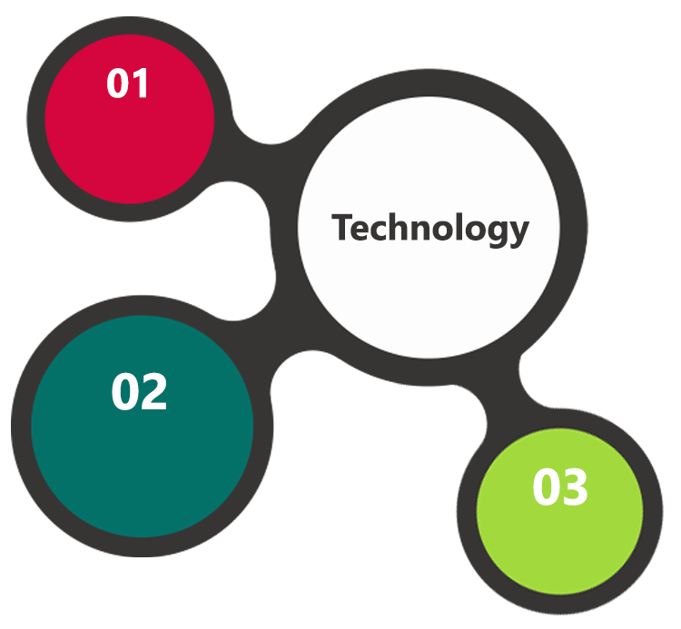

PHP  
CodeIgnitor

Apache, MySQL

HTML 5  
JavaScript  
CSS 3

## Web site Design

Development environment and specification of the project;

* Keeping the requirements into consideration, Verbat proposes   
  **A custom CMS based website using PHP/Code Igniter, MySQL, CSS3, HTML5**
* My SQL Server as the Database, Linux as the server operating system
* Apache as the Web Server

## Browser Compatibility

* Chrome version: 56
* Firefox version: 51
* Edge version: 39
* Safari 10.1

# Delivery Management

## Project Management

The Verbat development center strictly follows industry standards on quality. The project management is process governed by the Verbat Quality Management system and is put to verification through internal audit programs that happen from time to time.

Verbat will dedicate a project leader for the proposed implementation. Verbat proposes Client to identify one project manager who will be driving activities to be undertaken by Client to be the single point of contact for Verbat.

## Roles and Responsibilities

Verbat will assign a dedicated Project Lead to lead the project, who will be the first point contact for Client. He/she will be responsible for planning and managing the various activities within the project. He/she will work closely with Client Project Manager, to give periodic status updates and ensure high level of visibility and comfort on the progress of the project.

The Project Lead will lead the co-ordination between Verbat and Client, thus enabling smooth transitioning of Client requirements to the Verbat’s offshore delivery team, and provide visibility as well as comfort on the progress of the services to Client.

He/she will have periodic meetings with Verbat’s Senior Management, thus ensuring Verbat’s Management commitment and focus on Client initiatives.

## Delivery Activity summary

|  |  |
| --- | --- |
| **Activities** | **Description** |
| Detailed requirement Analysis | Verbat team to conduct detailed study of requirement for the phase. If clarification is required, team will reach out to Client for more information and/or time for discussions. |
| Website Wireframes | Once the requirement analysis is completed, Verbat team will submit the wireframes of the website for approval |
| UI/UX Design, Prototyping | Based on the confirmed wireframes, Verbat UX/UI team will work on the design concepts. Once the design is confirmed, Verbat team shall work on the prototype for approval |
| Development | Actual web design development starts based on the confirmed Prototype |
| Testing | Test Planning, test plan creations, internal, integration testing and user acceptance testing. |
| Deployment | Deploying the latest built in the Verbat Test Server. |

## Project Implementation Plan

Verbat will be providing the solution in a stand-alone fixed bid approach which ensures minimum viable solution for quick wins with core focus on the long-term business objective and outcome. Once the implementation is over, Verbat will initiate the application maintenance process (once the maintenance contract is signed) which continues to extend after the implementation.

## Deliverables

* Project plan
* Website Use-case
* Wire Frames for Key Screens
* Home Page Design Themes
* Prototype
* Fully Developed and Tested Website

## Deployment Details

If deployment is at the client’s server, responsibility of deploying the website onto the production environment after conducting the necessary acceptance testing will lie with the client unless and until Verbat’s support is contracted for deployment.

## Release Planning

* Client will be informed about the release date and time through email.
* Client performs the User acceptance testing (UAT)

## Risk and Contingency planning

Verbat has identified various risk factors associated with this assignment and understands the impact of these risk factors on the project schedules. The objective of this section is to highlight for both Verbat and client, the risk factors, to analyze the impact of the risks on project execution, and to propose strategies to control and reduce the impact of the risk factors.

These various risks, which could arise during the project, are tabulated below along with mitigation implementation.

| Type of risk | Impact | Risk Mitigation | Risk Handling |
| --- | --- | --- | --- |
| Scope Creep | H | Functions and features will be detailed in system requirement documents and will go through client approval. Once this document is approved, any change to requirement will go through change management review for possible impact assessment. | Proper change management procedure will be implemented. |
| Delay in customer feedback | H | The plan is prepared with enough lead-time for customer reviews and approvals.  The customer is indicated with the dates when the document is expected after review and approval. | The request for feedback will be escalated if not attended at the right time so that the schedules are not affected. Deemed acceptance criterion is set up front and will be followed. |
| Non-availability of necessary software’s, frameworks, database instances and infrastructure at client’s hosting environment(If hosting support is provided by Verbat) | M | Client will be informed in advance on these requirements. | Possible impact to schedule. |
| Manpower attrition | | L | All efforts would be made to ensure process dependence rather than being person dependent. As a risk mitigation plan Verbat will train backups. | A new person will be identified as early as possible, provided the required project-specific training and mentored by the senior members of the team to minimise impact of attrition on the project. |

*H-High, M-Medium, L-Low, NA-Not Applicable*

# Change Management

Any addition which comes out of the project scope, upon and after the launch of the tool will be considered as change management. Verbat recommends the following change management procedure for the same.

* Any change which comes out of the project scope, which was discussed, documented, and mutually approved by both the parties in the requirement stage, will be carried out only through raising a change request.
* Change request will be studied and an impact analysis on the existing work flow will be performed.
* On finalizing the impact, effort estimation for the change will be calculated and raised as additional requirement.
* Verbat will initiate the change request only after getting a formal approval from the client for the additional changes raised.
* 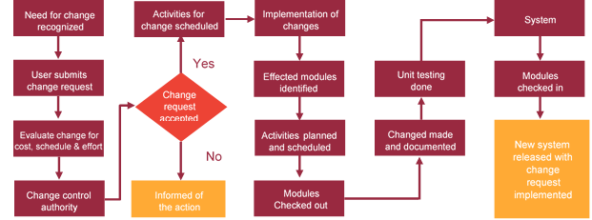**Any change from the scope will be charged at per man day effort and approval from the clients will be availed before commencing on any change management.**

# Miscellaneous

## Acceptance Criteria

* UAT sign off should happen within 14 Days from the release and the acceptance confirmation needs to be mailed to Verbat failing which Verbat will consider the project as approved by the client.
* Any comments or reason for rejection need to be documented and the same needs to be sent as an email from the official mail id of client to Verbat on or before 14 days from the first release.
* Timeframe for acceptance for any further release will be mutually agreed and finalized between client and Verbat depending on the UAT Comments

## Warranty

* Verbat shall provide a bug ﬁx warranty at no additional cost for 30 days from the date of acceptance of the project, for correction of any errors in the developed application that may be attributed to Verbat.
* However, this does not cover modifications by Client, or use of the application on an environment other than the proposed environment, or other circumstances outside Verbat’s reasonable control. In such a case Verbat reserves the right to charge for its services.
* All error corrections will be executed at Verbat India office. In the event of any need for on-site work, all expenses incurred for such trips will be payable to Verbat by Client.

## General Terms and Conditions

* Offer Valid for 30 calendar days from the date of submission of the Proposal
* An average of 20 working days are assumed in a month
* The works specified in this proposal shall be executed from our off-shore development center in India
* This proposal is based on the fair evaluation done with the requirement document submitted by the client. Verbat reserves the right to amend the terms of this proposal, should the SOW terms, functional features and functionalities change during the course of the project
* Verbat may either hardcode the design or shall purchase a theme that matches the design requirement specified by the client
* The website shall be built on the agreed use-case, wireframe. Any customization to the confirmed and purchased theme shall be executed through a defined change management process between both parties
* The page layouts that are confirmed by the client on the wireframes submitted for approval shall be final. Any customization beyond that is not considered in this proposal
* Website will be best viewed only in the environment mentioned in the document
* All Source Code and other project artefacts would adhere to the Verbat document templates and internal coding standards
* Acceptance criteria shall be based on the clauses which were mutually discussed between Verbat and client at the Requirement Analysis phase and the same will be documented and approved by both parties through official emails
* In case Client requires any extension of the proposed acceptance schedule, the associated effort and cost of such extension can be mutually reviewed.
* For any circumstances if project needs to be put on Hold / Stop it requires minimum request notice period of 30 days along with duration for which request will be addressed by management and final decision on the request will be based on that
* If deployment is done in client’s server, Verbat cannot be held responsible for any performance issues arising due to hardware malfunctions.
* Client is responsible for data backup in case the application is not hosted on Verbat server.
* Source code will only be delivered or uploaded on the Production Server once the due payments are made. Final deployment to production server pursuant to completion of all payments

## Assumptions and Dependencies

* Detailed system study is required before the start of the project.
* During the requirement gathering phase, authorized personnel from the Client’s side is expected to be available for discussion and finalizing the HLD (High Level Design), before development commences
* All queries regarding the client requirement and any queries which may hinder the project advancement at any stage should be answered by the client within 24 hours from the time of initiation, failing which the time delay will get added to the actual effort which was estimated
* Verbat assumes that all sign-offs from Client will be provided within agreed and specified timeframe. Any deviation to this shall affect the delivery timeline committed by Verbat
* Client will provide all the necessary contents, both text and image, before starting the project in the format suggested by Verbat
* The client should provide the relevant information and data well in time for the execution of a related activity. Non- availability of this information or data may lead to an interruption of work which may result in a delay in delivery as well as additional costs to the client

**UAE University**

Transportation

**Canada Cartage**

Construction

Services

* Client will be provided with one time training (train the trainer) on how to use the CMS (maximum of 2 hours). Additional training requests will be charged.

## Maintenance & Support

* Maintenance contracts by default are supported as per the basic SLA terms.
* AMC with Basic SLA is charged at 20 % of the total project value. Additional Effort / change management request will be added towards Total Value of the Project to determine the AMC value.
* Maintenance support is limited to providing application support for ensuring the consistency of the look-and-feel, bug fixes and user issues i.e. maintenance and support of the existing features of the website.
* Support does not in any way cover providing technical or other support to the end users. The maintenance agreement does not include functionality changes or feature additions which are handled as change requests which will be charged per man day. AMC does not include server support, maintenance and website deployment.
* AMC charges will cover Off-Site Support and Debugging. Support includes E-mail, Telephone and Chat unless explicitly specified. In the event, the application is hosted with the client; necessary remote desktop connectivity should be provided for carrying out maintenance activity.
* Gap in AMC - In case if the client does not opt an AMC for a year and want to renew it after that period, 50% of the AMC amount for the year for which AMC is not taken will also be payable if the client wishes to renew the AMC contract.

*Note:*

* *Please note that the AMC support shall start only after all the necessary signoffs*
* *(AMC Document) to this effect have been given*
* *It is not mandatory that the client should opt for an AMC. The client will still be Supported on an ad-hoc basis on an agreed man-day rate*
* *AMC Payment Terms: 100% to be paid as advance*

## Service Level Agreement

|  |  |  |  |
| --- | --- | --- | --- |
| Key | Max Response Time | Max Resolution Time | Target |
| Basic | 1  working day | 3 working days | Request / incident / problem tickets |
| Advanced | 5 Business Hours | 12 Business Hours | Request / incident / problem tickets |
| Priority | 3 Business Hours | 5 Business Hours | Request / incident / problem tickets |

***Note:-***

* *We provide Basic SLA as standard with AMC while Advanced and Priority SLAs attract additional charges.*
* *Time zone applicable as per India time zones (3:30 AM GMT to 12:30 PM GMT Monday to Friday)*

**AMC Option:**

* Client can opt for time and material based Annual Maintenance, the details of which will be shared post the completion of project.

We look forward to hearing from you soon and hope that you will give us the privilege to work with you in meeting your business goals. Thank you.

Thank You



©   
2018. All Rights Reserved   
Verbat Technologies   
www.verbat.com